|  |
| --- |
| A picture containing logo  Description automatically generatedInternational Institute of Yoga Therapy |

Symposium on Clinical Advancements in Yoga Therapy and Research 2025  
*Yoga Therapy as a First-Line Treatment in Health Care*   
  
Friday, Saturday, and Sunday, January 17, 18 and 19, 2025   
Westin Hotel Southfield, 1500 Town Center, Southfield, Michigan, USA, 48075

Continuing Medical Education (CME) credit will be available. Details coming soon!  
IAYT and Yoga Alliance CE approved.

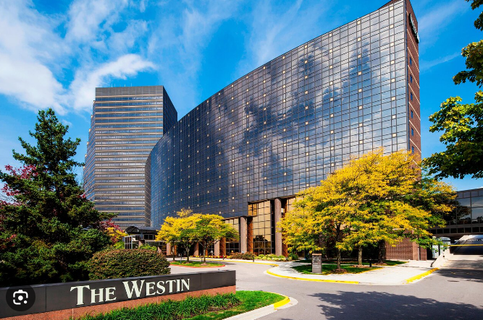

**IIYT Symposium on Clinical Advancements in Yoga Therapy and Research 2025  
 Poster Presentation**

**January 17-19, 2025  
Detroit, Michigan**

***Summary:*** Virtually submitted non-industry poster presentations will be offered during the times indicated in the final program. One poster from each of the four competition categories will receive an award.

Poster presentation submissions will adhere to four categories:   
1. Original research  
2. Muti-module aspects of yoga therapy within clinical healthcare environments

3. Benefits and challenges in research design development

4. Case reports: potentials for yoga therapy as a first line treatment of care

***Purpose:*** To improve the number and quality of poster submissions, to encourage, recognize, and promote visibility of presenters involved scholarly work in this field. To provide and motivate Symposium attendees to generate interest in clinical and research in muti-module aspects of health care.

***Poster scoring for competition:*** Scoring will be done by two judges: each vote on a selected poster submitted from each of the four categories. Each selection counts for 50% of the final score in each category. The judges will be members of the planning committee who have not made or have participated in any poster submissions. Attendees of the Symposium will also be invited to anonymously rate the posters during the poster session presentations as indicated on the final program. The average score of these ratings will become the fourth score.

Posters will be scored according to three categories on a 5-point scale (0 = Poor, 4 = Excellent):

1. **Relevance**: Utility (importance of study/project/intervention, impact, applicability to the multimodule aspects as applied to clinical advancements and/or research such as novel methodologies, ideas, approaches to implementation, communication within and among instar-professional systems and/or patients.
2. **Methodology and Result Highlights:** Clarity of description, initial questions motivating study, transparency in reporting methodology such as methods implemented, challenges of data collection and participant ‘buy-in’, accuracy in drop-out rate and causes, accuracy in literature searches, long and short-term sustainability, clarity of presentation, acknowledgement of collegiate team participation, non-bias outcome/results assessment, content, readability, brevity, originality,

***Poster Presentation Awards:***Winning posters (1st -4th place) will be announced at the conclusion of the Symposium on Sunday, January 19, 2025, as indicated on the final program. All four posters will be mentioned in the post-Symposium page on the IIYT website. The poster selected as the winner will be published on the IIYT Website.

***How to Electronically Submit your Poster: PLEASE NOTE – ALL Poster presentations application forms and poster presentations accepted will be electronically submitted***

1. Complete the Poster Presentation Application Form (below) and return to [vzador@iiyogathearpy.com](mailto:vzador@iiyogathearpy.com) on or before **12:00 AM EST Sunday, December 8, 2024.**
2. You will be electronically notified if your poster has been accepted for presentation on Sunday, December 22, 2024. You will also receive a Symposium Poster Presentation template slide for your use in developing your PPT.
3. If your poster has been accepted for presentation, you and your co-authors will need to register for the Symposium to be eligible for presentation and participation in the poster session presentation and judging process. Off-site virtual presentations are not permitted.
4. Posters selected will be presented electronically during session times as indicated on the final program.
5. For additional information please contact: [**vzador@iiyogatherapy.com**](mailto:vzador@iiyogatherapy.com)

**IIYT Symposium on Clinical Advancements in Yoga Therapy and Research 2025  
 Poster Presentation Application Form**

**January 17-19, 2025  
Detroit, Michigan**

**Presenting Primary Author:**

**Additional Authors:**

**Presenter Contact Name:**

**Email:**

**Phone:**

**Address:**

**Select Category:**

__ 1. Original research  
__ 2. Muti-module aspects of yoga therapy within clinical healthcare environments

__ 3. Benefits and challenges in research design development

__ 4. Case reports: potentials for yoga therapy as a first line treatment of care

**Please limit total description of your poster to 300 words:**

**Poster Title:**

**Introduction:**

**Relevance:**

**Methodology and Result Highlights:**

**Please submit this form to** **[vzador@iiyogatherapy.com](mailto:vzador@iiyogatherapy.com) with the Subject Line reading: Poster Presentation Application Symposium 2025 on or before 12:00 AM EST on Sunday, December 8, 2024**